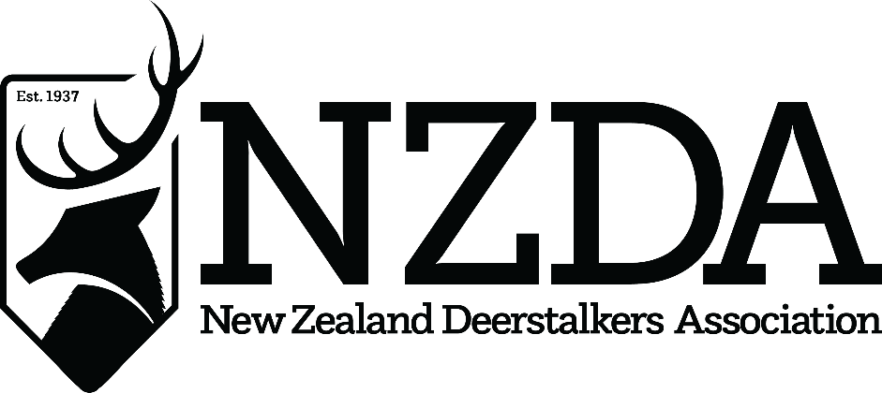

78th National Conference
Hosted by NZDA National Association
24th – 26th July 2026

APOLOGIES REGISTER

………………………………………………………………………………………………………………………………………………………………………………………………………………………………………………………………………………………………………………………………………………………………………………………………………………………………………………………………………………………………………………………………………………………………………………………………………………………………………………

Branch: ……………………………………………………………………………………

Do you want your apology listed in the conference handbook?

No
(PLEASE TICK)
Yes listed

